## horizontal line

Group Project 2015 - Design Specification

**Group 07**

**Authors:** K. Hodges, T. Doyle, C. Bassi, I. Gombar, J. Hallam, G. Heard, E. Dugdale.

**Config Ref:**  SE.QA.05A

**Date:** 27-10-2015

**Version:**  1.1

**Status:** Release

Department of Computer Science,

Aberystwyth University,

Aberystwyth,

Ceredigion, SY23 3DB,

U.K

Copyright © Aberystwyth University 2015

**CONTENTS**

1. INTRODUCTION

1.1 Purpose of this document

1.2 Scope

1.3 Objectives

2. DEPLOYMENT DESCRIPTION

2.1 Applications in the system

2.2 Application interactions

3. INTERACTION DESIGN

3.1. Use-cases

3.2. TaskerMan User interface design

3.3. TaskerCli User interface design

4. COMPONENT DESCRIPTION

5. SIGNIFICANT CLASSES

5.1. Interface Description

6. DETAILED DESIGN

6.1. Sequence diagrams

6.2. State diagrams

6.3. Activity diagrams

6.4. Significant data structures

# 1. INTRODUCTION

## 1.1 Purpose of this document

The purpose of this document is to provide a design overview for the interaction and high-level design of our group project.

## 1.2 Scope

This overview design specification aims to provide information about the initial design for our system “Tasker”, giving information about the components in our system and how they will interact. Use-case diagrams will be used to then demonstrate system functionality, with corresponding user interface designs to show how a user would execute these actions.

## 1.3 Objectives

The objectives of this document are:

* To describe the deployment of the applications in our system:
  + Deployment of takserMAN, taskerCLI and taskerSRV
  + How these applications will interact with one another (where appropriate)
* To outline system design:
  + Use-case diagrams to show how the user would interact with the system
  + Designs of the user interface for each application (as listed above)

# 2. DEPLOYMENT DESCRIPTION

## 2.1 Applications in the system

We will employ many different applications within the system. The three subsystems we will be using within the system will be taskerCLI, taskerMAN and taskerSRV.

TaskerCLI

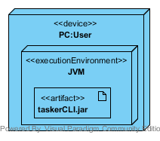

TaskerCLI will be a Java desktop application run in the JVM on a user’s computer(s). It is designed to be used by users who have task(s) assigned to them by the manager in the taskerMAN application. A user will sign onto the system using their e-mail, and this is how they will be able to receive user-specific tasks assigned to them by the manager. Synchronisation between taskerSRV and taskerCLI will also be implemented.

The user can view, update and provide information on the tasks they have been assigned such as writing comments about task elements as they are being worked on, reading comments left by their manager on task elements as well as requesting to change a task status to be abandoned, although this will be have to be confirmed by the manager using taskerMAN.

Thus, the primary use of the taskerCLI will be to allow users to easily provide feedback on their progress with assigned tasks, including any problems encountered, whilst also being able to see all tasks assigned to them by their manager, allowing them to easily keep track of their workload.

TaskerMAN

TaskerMAN will be a web based application running on an Apache web server. It will be used by the manager to assign tasks to users in a group. The manager has open access to the TaskerMAN application at any time using the web.

The manager can create and assign tasks to users, as well as having most of the functionality available to users in TaskerCLI. They can also approve or deny requests to change the task status.

TaskerSRV

The TaskerSRV will be an Apache web server running PHP and a MySQL database. It will be able to hold, edit, and create team member data (full name and e-mail address) and task data (task title, allocated team member, start date, expected completion date, a list of task elements and a status).

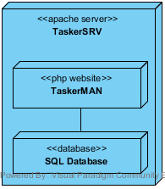

## 

## 

## 

## 

## 2.2 Application interactions

TaskerMAN and TaskerSRV

With TaskerMAN, the following information will be received from and stored in the database located on on TakserSRV:

* Relating to users:
  + First name
  + Last name
  + E-mail address
* Relating to tasks:
  + Task title
  + Allocated team member
  + Start date
  + Expected completion date
  + List of task elements
  + Status

TaskerCLI and TaskerSRV

With TaskerCLI, the following information will be received from and stored in the database located on TaskerSRV:

* User email (to authorise user access).
* Relating to task(s):
  + Task title
  + Start date
  + Expected completion date
  + List of task elements
  + Free text section for comments relating to each task element
  + Ability to flag tasks as “complete” (for review by the manager)

The diagram below shows the interaction between all components of the TaskerSRV, TaskerMAN and TaskerCLI.

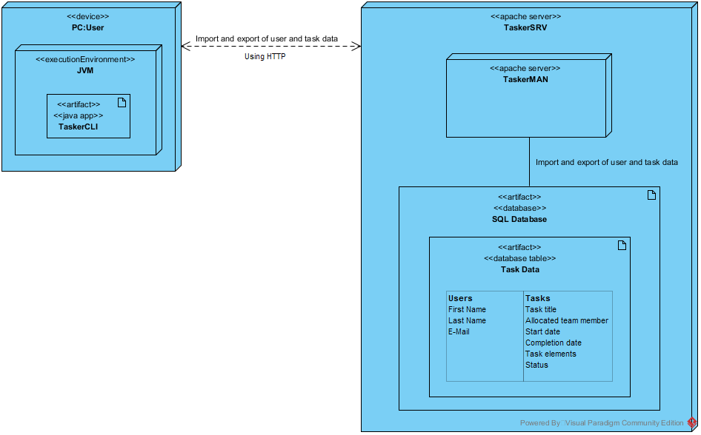

# 

# 3. INTERACTION DESIGN

## 3.1. Use-cases

The diagram below shows the interaction between TaskerCLI and the employee using it.

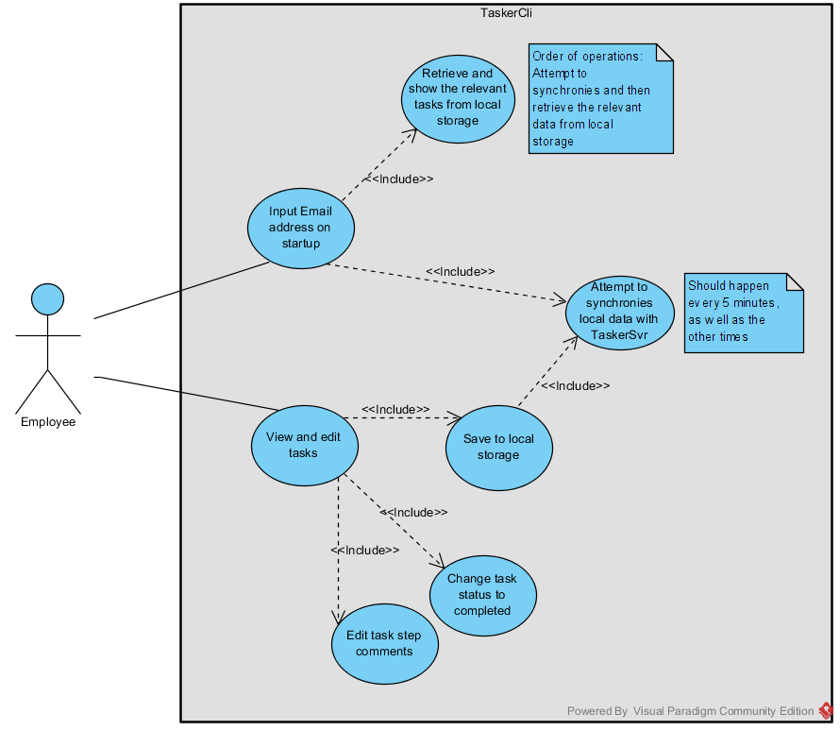

The user must input their email address (as seen in the top use case) before being able to proceed. The system then attempts to update the locally stored tasks with the tasks on TaskerSRV. All tasks then will be loaded from local storage even if synchronization failed.

The user can then view any of their assigned tasks, edit the comments for any of the provided task elements and/or change the status of the task to completed. After any edits have been confirmed the program first saves any changes to local storage and then attempts to synchronise with TaskerSRV. For example the user might want to update a task to tell the manager that 2 more of the task steps have been completed by editing the comments for those task steps. Another user might want to set a recently finished task to completed.

The second use case diagram shows the interaction between TaskerMAN and the manager.

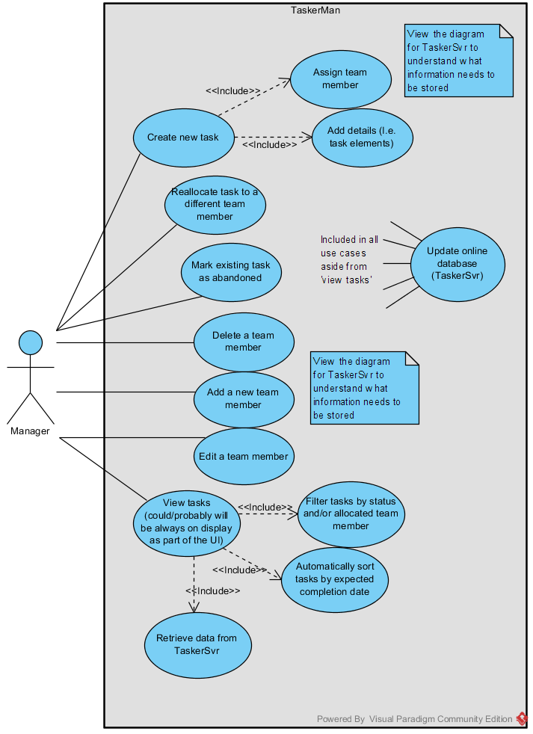

The manager does not have to log on to start using the application, although we may include this feature in future. The application will have to be able to retrieve all of the task data from TaskerSRV and show the manager a list of all of the tasks, sorted by expected completion date. The manager must have the option to be able to filter this list as described in the diagram.

The manager must be able to make changes to existing tasks and create new tasks. The creation of new team members must also be supported as well as the ability to edit or delete existing team members. All changes should then be communicated with TaskerSRV.

For example the manager might want to view each task assigned to “M. Jones” that are marked as “allocated”. This will allow the manager to keep updated on the progress being made for each task assigned to that employee. They might want to assign one of those tasks to a different user or mark a now unnecessary task as abandoned.

## 3.2. TaskerMAN User interface design

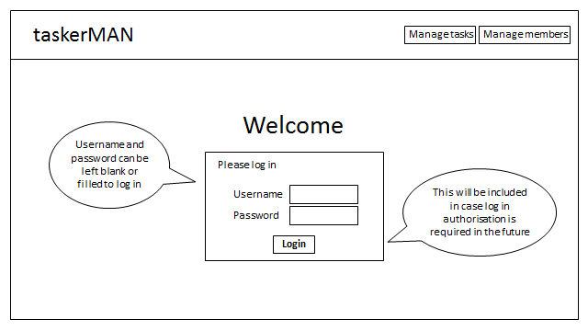

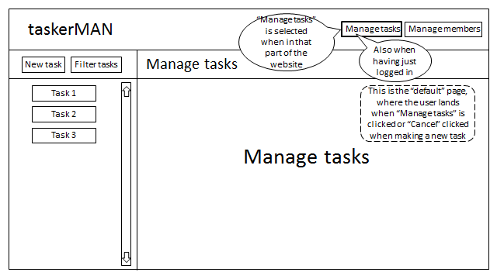

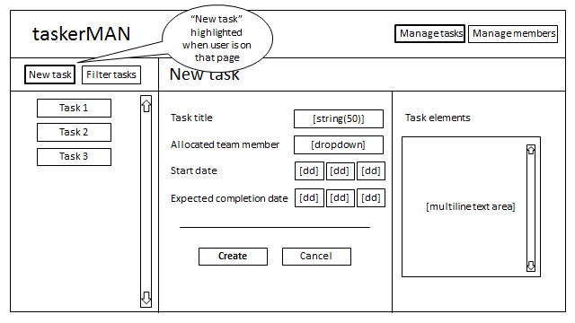

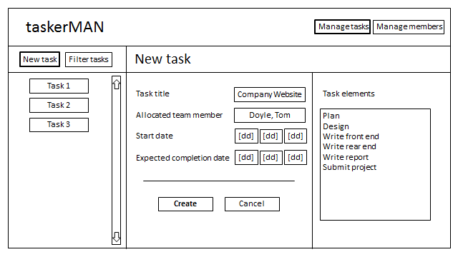

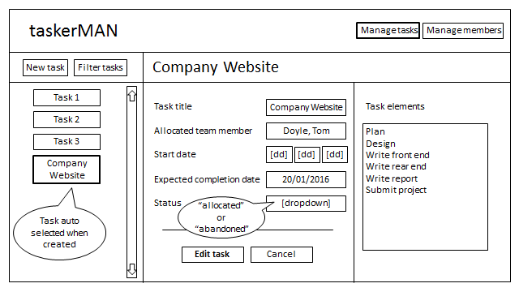



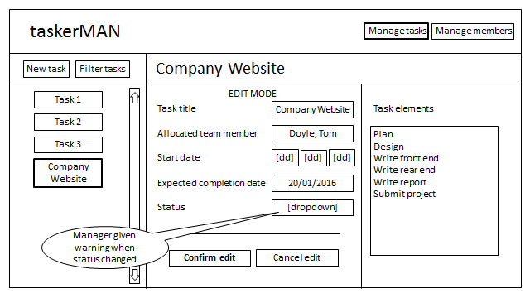

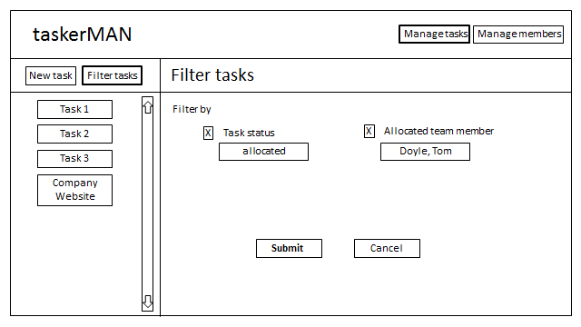

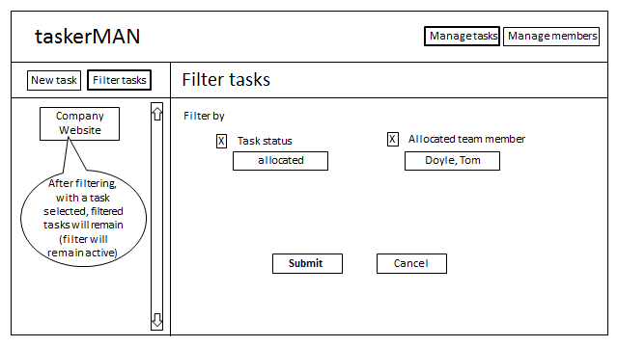

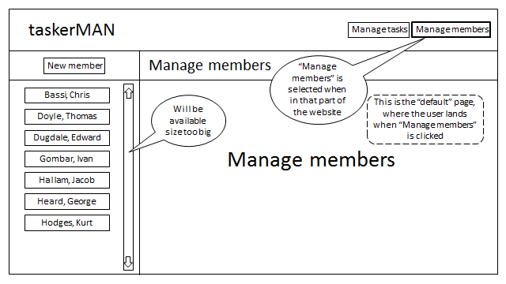

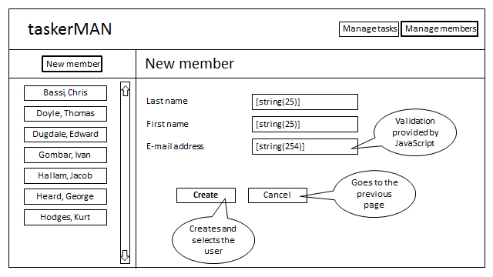

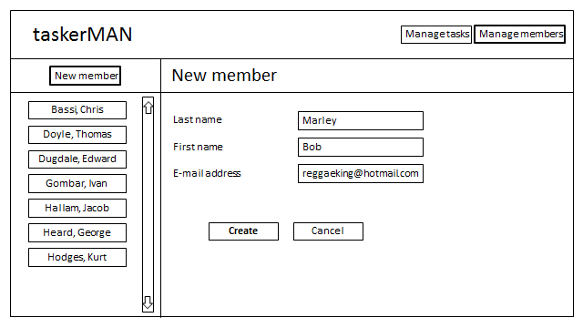

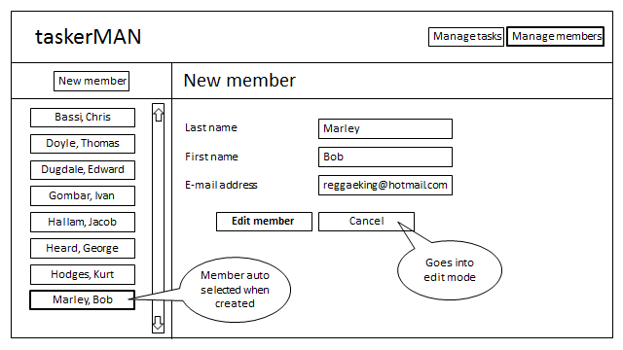

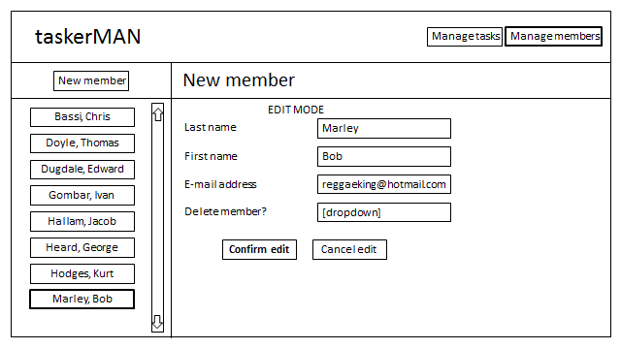

## 3.3. TaskerCLI User interface design

